**Course Name: Operating systems Talal Khan**

**LAB: 10 DT-22043**

**Exercise:**

1) Implement the above code and paste the screen shot of the output.

**PROGRAM:**

|  |
| --- |
| #include <stdio.h>  #include <conio.h>  int main() { int ms, ps, nop, np, rempages, i, j, x, y, pa, offset; int s[10], fno[10][20];    //clrscr();  printf("\nEnter the memory size -- "); scanf("%d", &ms);  printf("\nEnter the page size -- "); scanf("%d", &ps);  nop = ms / ps; rempages = nop;  printf("\nThe no. of pages available in memory are -- %d", nop); printf("\nEnter number of processes -- "); scanf("%d", &np);  for (i = 1; i <= np; i++) { printf("\nEnter no. of pages required for p[%d] -- ", i); scanf("%d", &s[i]);    if (s[i] > rempages) { printf("\nMemory is Full"); break;  }    rempages -= s[i];  printf("\nEnter page table for p[%d] ---\n", i); for (j = 0; j < s[i]; j++) { printf("Page %d -> Frame: ", j); scanf("%d", &fno[i][j]);  }  } printf("\nEnter Logical Address to find Physical Address"); printf("\nEnter process no., page number and offset -- "); |

**LAB-10 (MEMORY MANAGEMENT TECHNIQUES)**

**CT-353 EzaanKhan DT-22046**

|  |
| --- |
| scanf("%d %d %d", &x, &y, &offset);  if (x > np || y >= s[x] || offset >= ps) { printf("\nInvalid Process or Page Number or Offset");  } else { pa = fno[x][y] * ps + offset; printf("\nThe Physical Address is -- %d", pa); } getch(); return 0;  } |

**OUTPUT:**

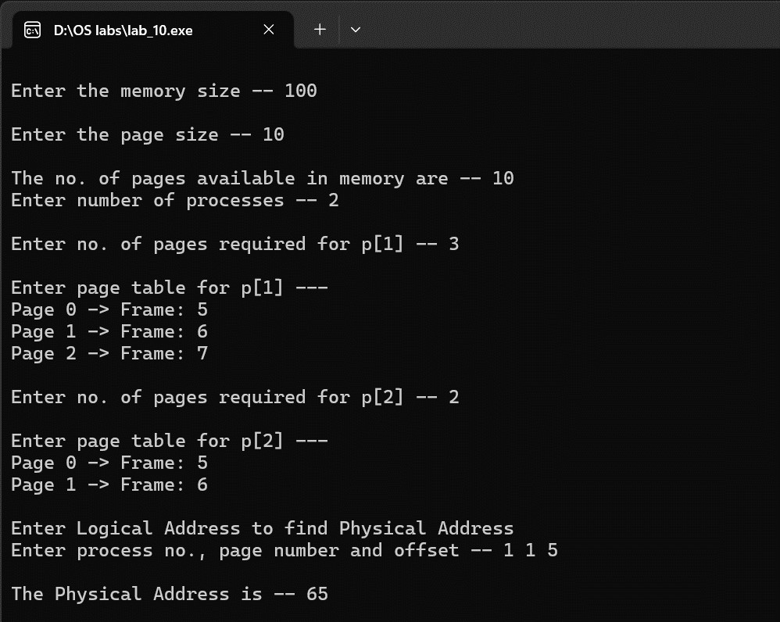

**LAB-10 (MEMORY MANAGEMENT TECHNIQUES)**